**SDUI5Preferences Dialog**

This dialog is a user interface component that allows users to create simple forms for CRUD apps and or configure application settings, preferences, or options. These dialogs typically provide controls like checkboxes, radio buttons, dropdowns, sliders, and input fields to let users customize the behavior and appearance of the application and or enter and retrieve database records.

1. Open the SithasoDaisy5 Demo App from this URL, <https://sithaso-daisy5.vercel.app/>
2. Click PlugIns > Preferences

Below are example of these forms.

**Figure 1**

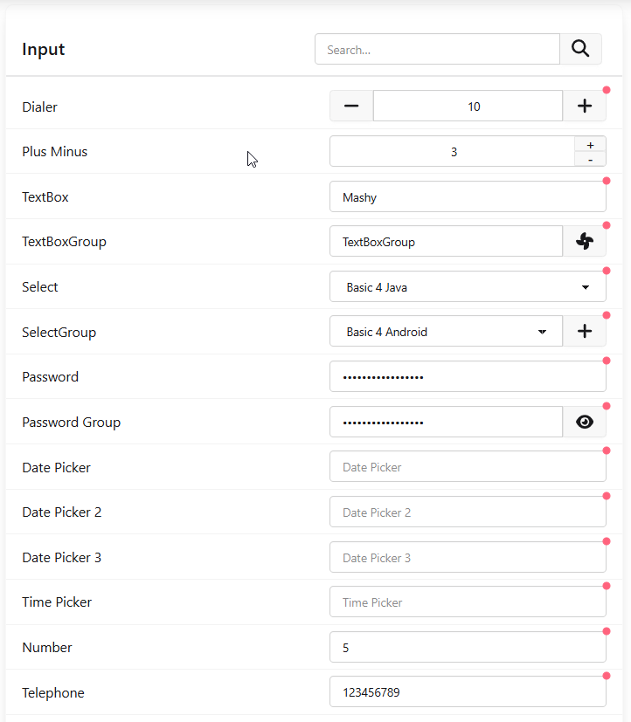

**Figure 2**

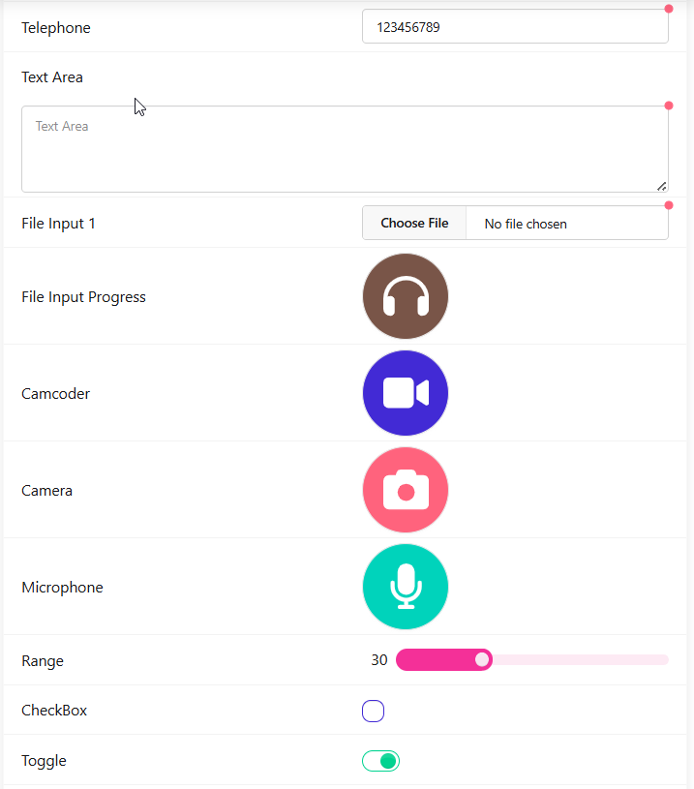

**Figure 3**

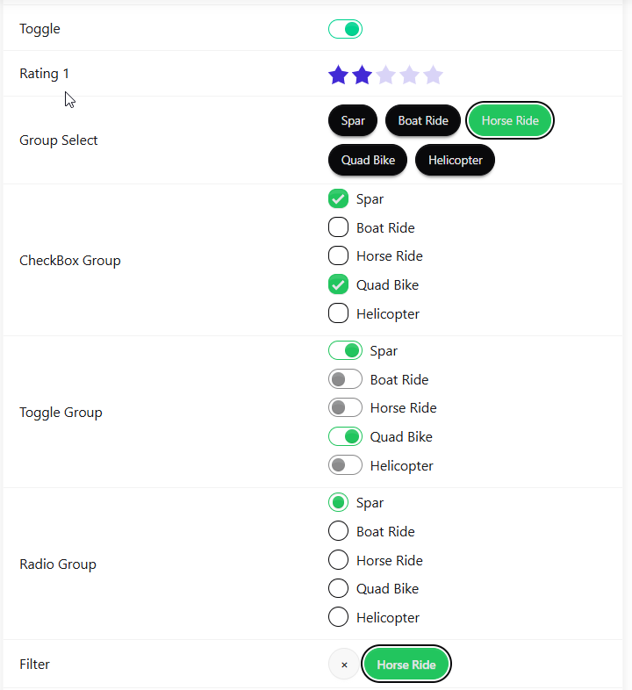

**Figure 4**

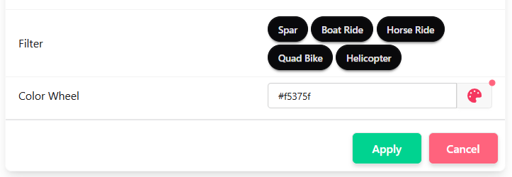

As noted above, this dialog can have different types of input components for data entry. One is also able to configure which buttons to show as actions at the end of the dialog. These can be yes, no, cancel.

Whilst one is able to enter data, one is also able to view existing data. These displays can also depend on the data entered in these input components.

**Figure 5**

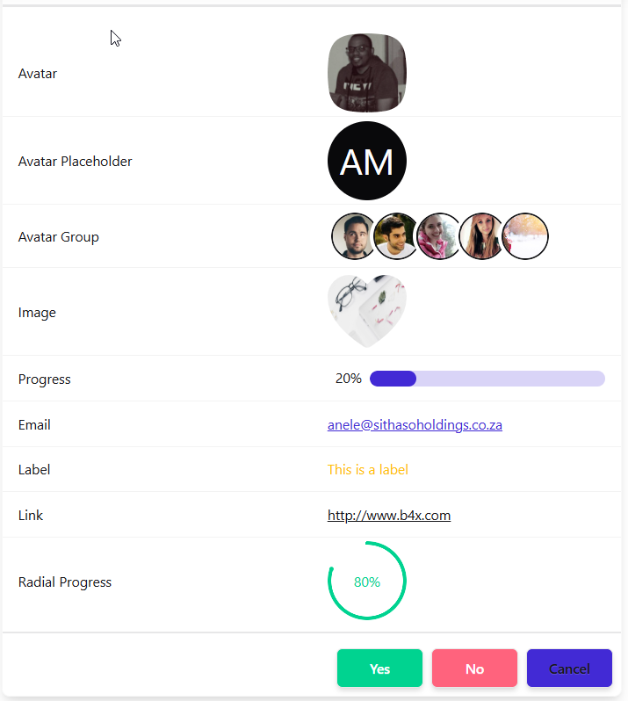

**Creating the Forms**

The form you see above can be created in two ways, 1. Via b4x code and 2. Via a list JSON objects. In both these instances we can use the **Preference Dialog Forms Builder** aka **PDFB** a tool specifically created to build such forms.

**Using the Preferences Dialog Forms Builder**

1. Open the SithasoDaisy5 Demo App from this URL, <https://sithaso-daisy5.vercel.app/>
2. Click PlayGround > Preferences Dialog Builder

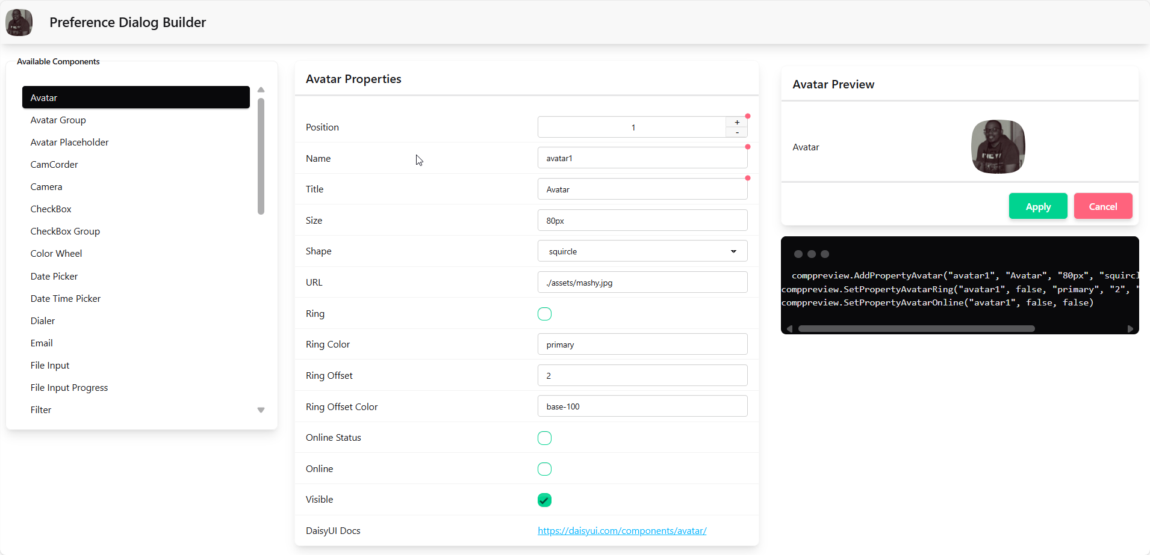

The builder allows you to create each component you will use for your form. Its split into 4 sections, 1. Components, 2. Properties and 3. Preview and 4. B4x source code to create same component.

You first select the component you want to add to your form from the list provided, then set its properties and then you can see how it will look like based on the settings you have provided. The code section will show you the b4x source code to create the component based on the properties you have set.

*NB: In the next tutorials we will look at how we can create complete forms, for now lets look at each component we have already created in our examples above.*

**Using b4x code to create the form.**

Below we look at each component that you can have on the Preference Dialog and what it means and how you can enter it. The PDFB will generate the code for you and you can also download the forms definition to a JSON object file.

**Input Properties & b4x code**

| **B4x Source Code** | **Output** |
| --- | --- |
| Dialer allows users to increase or decrease a numeric value using increment (+) and decrement (-) buttons.   * AddPropertyDialer("dialer1", "Dialer", "10", True, 0, 5, 100) |  |
| Plus Minus is a simple input field with minus and plus append icons for number picking   * AddPropertyPlusMinus("plusminus", "Plus Minus", "3", False, "0", "1", "12") |  |
| Text Input is a simple input field.   * AddPropertyTextBox("textbox1", "TextBox", "Mashy", True) |  |
| Text Box Group is a simple input field that can have prepend and append icons.   * AddPropertyTextBoxGroup("textboxgroup1", "TextBoxGroup", "TextBoxGroup", True) * SetPropertyAppendIcon("textboxgroup1", "./assets/fan-solid.svg") |  |
| Select is used to pick a value from a list of options.   * AddPropertySelect("select1", "Select", "b4j", True, CreateMap("b4a": "Basic 4 Android", "b4i": "Basic 4 iPhone", "b4j": "Basic 4 Java", "b4r": "Basic 4 Arduino")) |  |
| Select is used to pick a value from a list of options and can have prepend and append icons.   * AddPropertySelectGroup("selectgroup1", "SelectGroup", "b4a", True, _   CreateMap("b4a": "Basic 4 Android", "b4i": "Basic 4 iPhone", "b4j": "Basic 4 Java", "b4r": "Basic 4 Arduino"))   * SetPropertyAppendIcon("selectgroup1", "./assets/plus-solid.svg") |  |
| Password is an input field with password type.   * AddPropertyPassword("password0", "Password", "anythingcanhappen", True) |  |
| Password Group is a simple password type input field with append icon   * AddPropertyPasswordGroup("password1", "Password Group", "anythingcanhappen", True) |  |
| Date Picker is an input field that shows a date picker.   * AddPropertyDatePicker("datepicker1", "Date Picker", "", True, "Y-m-d", "F j, Y", "en") |  |
| Date Picker is an input field that shows a date picker and can also be customized to use other locales   * AddPropertyDatePicker("datepicker2", "Date Picker 2", "", True, "Y-m-d", "j F, Y", "ru") |  |
| Date Time Picker is an input field that shows a date time picker.   * AddPropertyDateTimePicker("datepicker3", "Date Picker 3", "", True, "Y-m-d H:i", "j F, Y H:i", True, "en") |  |
| Time Picker is an input field that shows a time picker.   * AddPropertyTimePicker("timepicker1", "Time Picker", "", True, "H:i", "H:i", True, "en") |  |
| Number is an input field with number type.   * AddPropertyNumber("number1", "Number", "5", True) |  |
| Telephone is an input field with telephone type.   * AddPropertyTelephone("telephone1", "Telephone", "123456789", True) |  |
| Textarea allows users to enter text in multiple lines.   * AddPropertyTextArea("textarea1", "Text Area", "", True, "") |  |
| File Input is a an input field for uploading files.   * AddPropertyFileInput("fileinput1", "File Input 1", True, "", False) |  |
| File Input Progress – shows a button with a custom icon and will show a radial progress during execution   * AddPropertyFileInputProgress("fileinputprogress1", "File Input Progress", "80px", "./assets/headphones-solid.svg", "42px", app.COLOR_BROWN, "#ffffff") |  |
| File Input Progress (Camcorder) – shows a button with a video icon and will show a radial progress during execution. This activates a camera on mobile for video recording   * AddPropertyCamCorder("camcoder1", "Camcoder", "80px", "42px", app.COLOR_PRIMARY, "#ffffff") |  |
| File Input Progress (Camera) – shows a button with a camera icon and will show a radial progress during execution. This activates a camera on mobile   * AddPropertyCamera("camera1", "Camera", "80px", "42px", app.COLOR_ERROR, "#ffffff") |  |
| File Input Progress (Microphone) – shows a button with a microphone icon and will show a radial progress during execution. This activates a voice recording on mobile   * AddPropertyMicrophone("microphone1", "Microphone", "80px", "42px", app.COLOR_ACCENT, "#ffffff") |  |
| Range slider is used to select a value by sliding a handle.   * AddPropertyRange("range1", "Range", "30", app.COLOR_SECONDARY, "0", "1", "100") |  |
| Checkboxes are used to select or deselect a value.   * AddPropertyCheckBox("checkbox1", "CheckBox", False, app.COLOR_PRIMARY) |  |
| Toggle is a checkbox that is styled to look like a switch button.   * AddPropertyToggle("toggle1", "Toggle", True, "success") |  |
| Rating is a set of radio buttons that allow the user to rate something.   * AddPropertyRating("rating1", "Rating 1", "2", "primary", app.MASK_STAR_2) |  |
| Group Select allows users to select multiple options or a single option from items that are categorized.   * Dim gsOptions As Map = app.UI.GetKeyValues("spar:Spar; boatride:Boat Ride; horseride:Horse Ride; quadbike: Quad Bike; helicopter:Helicopter", False) * AddPropertyGroupSelect("groupselect1", "Group Select", "spar;quadbike", "neutral", False, "#22c55e", gsOptions) * SetPropertyValue("groupselect1", "horseride") |  |
| Check Box Group allows users to select one or more options from a list using checkboxes.   * AddPropertyCheckBoxGroup("checkboxgroup1", "CheckBox Group", "spar;quadbike", "neutral", "#22c55e", gsOptions) |  |
| Radio buttons allow the user to select one option from a set.   * AddPropertyToggleGroup("togglegroup1", "Toggle Group", "spar;quadbike", "neutral", "#22c55e", gsOptions) |  |
| Radio buttons allow the user to select one option from a set.   * AddPropertyRadioGroup("radiogroup1", "Radio Group", "spar", "neutral", "#22c55e", gsOptions) |  |
| Filter is a group of radio buttons. Choosing one of the options will hide the others and shows a reset button next to the chosen option.   * AddPropertyFilter("filter1", "Filter", "horseride", "neutral", "#22c55e", gsOptions) |  |
| The color wheel is used to pick a color from a palette.   * AddPropertyColorWheel("color1", "Color Wheel", "#f5375f", True, 16, 200, 20, "top-end") |  |

**Display Properties**

| **B4x Source Code** | **Output** |
| --- | --- |
| Avatars are used to show a thumbnail representation of an individual or business in the interface   * AddPropertyAvatar("avatar1", "Avatar", "80px", app.MASK_SQUIRCLE, "./assets/mashy.jpg") |  |
| Avatar Placeholder","Avatar Placeholder is used to show text inside an avatar.   * AddPropertyAvatarPlaceholder("avatarplaceholder", "Avatar Placeholder", "AM", "80px", app.MASK_CIRCLE, app.COLOR_NEUTRAL, "white", app.TEXTSIZE_4XL) |  |
| Avatar Groups are used to show a collection of thumbnails representation of an individual or business in the interface.   * AddPropertyAvatarGroup("avatargroup", "Avatar Group", "12", app.MASK_CIRCLE, _   Array("./assets/1.jpg", "./assets/2.jpg", "./assets/3.jpg", "./assets/4.jpg", "./assets/5.jpg")) |  |
| Image is used to show an image that can be have a cropped content of the element to common shapes   * AddPropertyImage("image1", "Image", "80px", "80px", app.MASK_HEART, "./assets/10.jpg") |  |
| Progress bar can be used to show the progress of a task or to show the passing of time.   * AddPropertyProgress("progress1", "Progress", "20", app.COLOR_PRIMARY, "0", "2", "100") |  |
| Emails shows a link to an email address.   * AddPropertyEmail("email1", "Email", "anele@sithasoholdings.co.za", app.COLOR_PRIMARY) |  |
| Label shows a text label.   * AddPropertyLabel("label1", "Label", "This is a label", app.COLOR_AMBER) |  |
| Link shows a link you have provided   * AddPropertyLink("link1", "Link", "http://www.b4x.com", app.COLOR_FUCHSIA) |  |
| Radial progress can be used to show the progress of a task or to show the passing of time.   * AddPropertyRadialProgress("radialprogress", "Radial Progress", "80", "success", "5rem", "4px") |  |